Estimating the concentrate nitrogen in cattle feed

Introduction

Extensive milk and meat production can be supported by the energy available in diets that consist solely of roughage (e.g. grass, maize silage). As milk or meat production per cow increases, a ration solely based on roughage is incapable of supplying the energy required. The rumen has a finite capacity to decompose such fibrous feeds, setting a limit to the rate at which the ration can supply energy. To increase the rate at which energy is supplied, part of the roughage in the feed ration is replaced by feedstuffs containing a higher concentration of energy and a lower concentration of fibre. When estimating the removal of N in roughage crops using the approach adopted by Oenema et al, it is necessary to account for the N supplied in concentrate feed.

Dairy cows

The milk production per cow varies quite substantially in space and time, with the consequence that the contribution of concentrate feedstuffs to the feed ration also varies substantially. To account for the variation in concentrate feeding due to differences in milk production, it is necessary to estimate the roughage and concentrate contributions that would supply the energy required to achieve the measured milk production. Since concentrate feedstuffs are generally more expensive than roughage feedstuffs, it is assumed that the farmers feed a ration that minimises the amount of concentrates fed.

A number of systems exist that allow intake and production to be estimated, based on the characteristics of the livestock and feed. The system used here is the NorFor system (Volden (2011). This system uses the Scandinavian Feed Unit (SFU) as a measure of the energy content of feed (equal to about 8.9 MJ (kg DM)-1) and abstract Fill Units (FU) to describe the maximum intake capacity of the rumen and the extent to which a unit mass of individual feedstuffs occupy that capacity. The maximum intake capacity is a function of the body weight of the cow, the milk yield, the day of lactation and the extent to which body reserves are used/deposited. The fill units of a feed (FE (kg DM)-1) is a function of the organic matter digestibility and both the NDF and readily degradable carbohydrate (sugar + starch) contents of the feed. The maximum intake of a given ration is the maximum intake capacity, divided by the fill density (FE (kg DM)-1) of that ration. The energy provided by a given ration is the product of the dry matter intake (DMI) and energy content of the ration (SFU (kg DM)-1). The energy required to produce a given milk yield is expressed in SFUs and is a function of the milk yield.

The procedure used to estimate the mass of concentrate fed is shown in Fig 1.

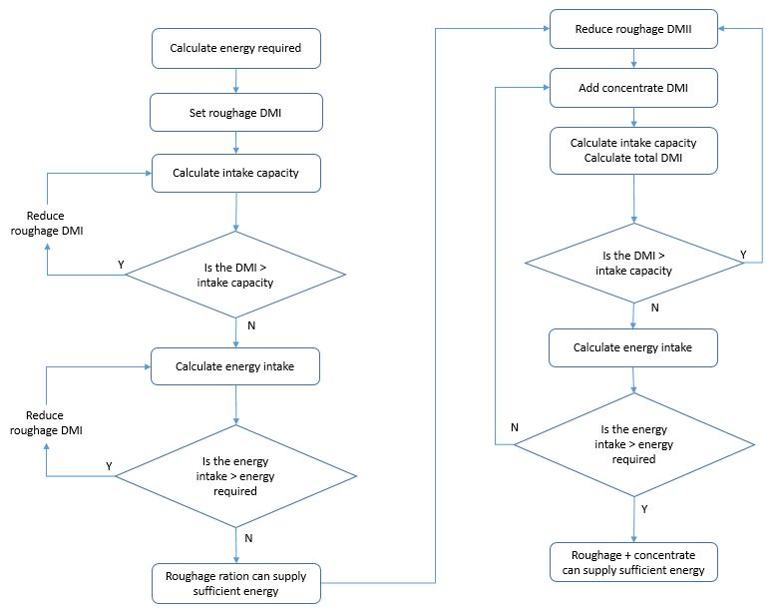

Fig 1 Procedure to calculate the roughage and concentrate feed required to achieve a given milk yield

Once the mass of concentrate feed required has been determined, the N supplied in the concentrate feed within a given area is then:

N in concentrate = no of cows \* concentrate feed per cow \* N content of concentrate feed

The N in concentrate can then be subtracted from the estimated N intake per cow, to obtain the N consumed in roughage.

The parameters used in the calculations are as follows:

Body weight of cow = 650 kg

Energy content of roughage feed = 0.81 SFU (kg DM)-1

Organic matter digestibility of roughage feed = 70%

NDF content of roughage feed = 330 g (kg DM)-1

Sugar + starch content of roughage feed = 12.5 g (kg DM)-1

Energy content of concentrate feed = 1.22 SFU (kg DM)-1

Organic matter digestibility of concentrate feed = 90%

NDF content of concentrate feed = 9 g (kg DM)-1

Sugar + starch content of concentrate feed = 69.2 g (kg DM)-1

Nitrogen content of concentrate = 20 g (kg DM)-1

The values for roughage equate to a grass of average quality. The values for concentrate equate to those of wheat meal.

The maximum intake capacity was calculated on a daily basis for 271 days and the results averaged.

Results

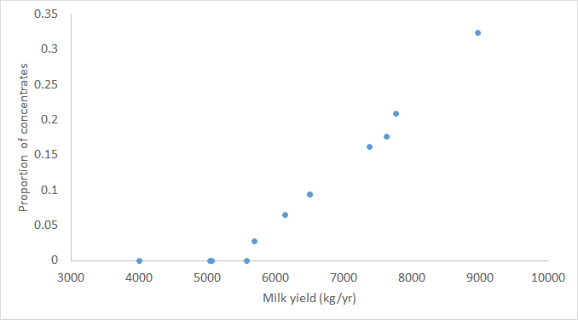

References

Volden, H. (ed) (2011) NorFor - The Nordic Feed Evaluation System Scientific series, EAAP 130. <https://doi.org/10.3920/978-90-8686-718-9>.

Pseudocode for VBA calculations

Start:

Read location (if cell is empty, then move to End)

Read milk yield

If milk yield = 0, skip to next milk yield

else

Set roughage intake high

Reduce roughage intake until FV=<IC.

Check if FE enough to satisfy milk yield. If so, finish (100% roughage diet) and move to start

Else

Reduce roughage DM intake by 1 kg/day. Increase concentrate DM intake in 0.1 kg increment

Check if FV>IC or milk yield could be achieved

If FV>IC, reduce roughage intake by 1kg/day and repeat

Else finish this milk yield and move to start.

End: